 

**Placement Empowerment Program**

***Cloud Computing and DevOps Centre***

**DAY 1 TASK:**

Set Up a Local Git Repository: Initialize a Git repository locally and version control your static website

NAME: NITHYASRI S.K

DEPARTMENT: ADS

**INTRODUCTION AND OVERVIEW:**

As day 1 task,we are going to do handson on how to host a static website locally using Apache HTTP server. It involves process like setting up local server, configuring it and hosting html page .

**EXPECTED OUTCOME:**

By the end of this POC, we will be able to configure and run Apache server locally and Host a static HTML website.

**GUIDANCE TO DO THE TASK:**

STEP 1:

* Search for Apache Lounge on Google Chrome and download from the official website.
* Click on Downloads on the left side of the website and download the suitable version required.

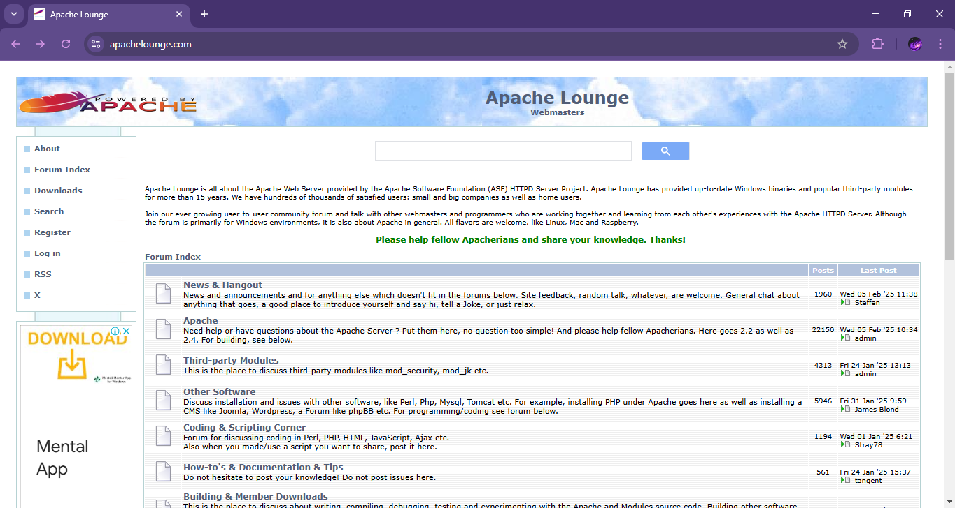

STEP 2:

* Extract all files from the downloaded zip file.

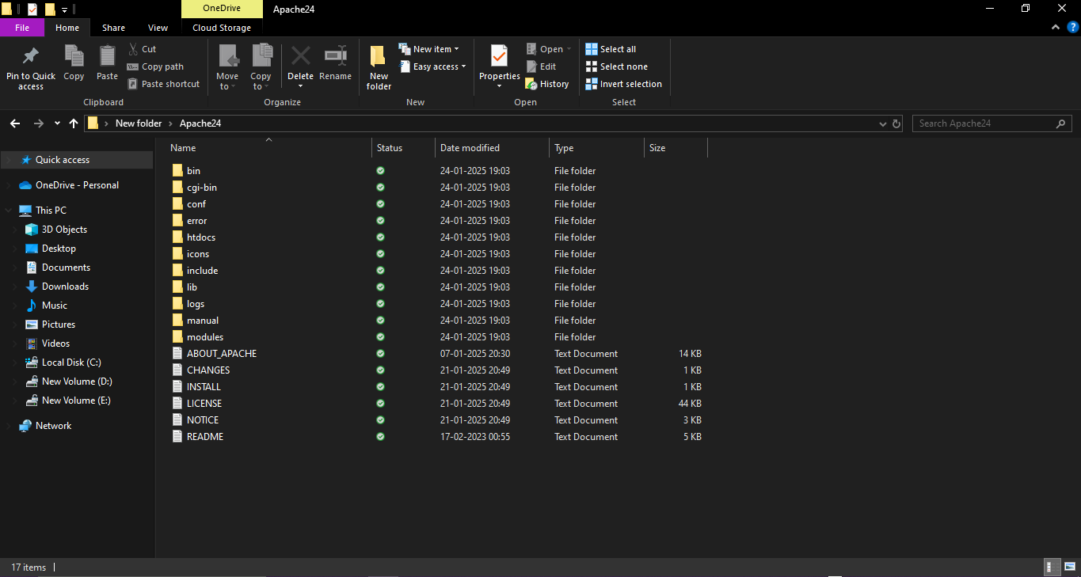

STEP 3:

* After extracting the files, open the cmd as Administrator.
* Use the following command to set path to the Apache bin folder. Run the installation command : httpd.exe –k install



STEP 4:

* Navigate to Apache folder and go to conf folder.
* Right click on httpd.conf file,select ‘Edit with Notepad’

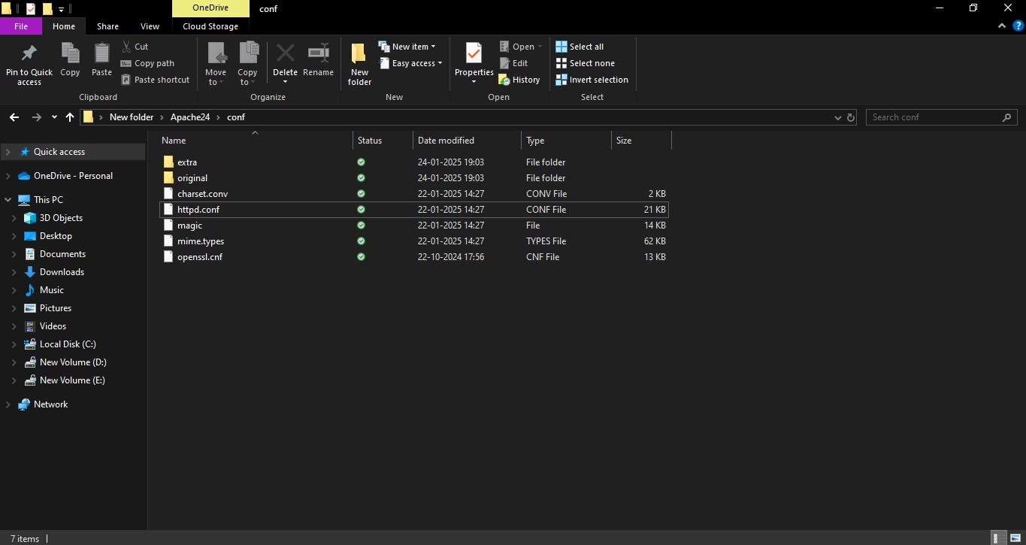

STEP 5:

Open cmd to test and type the command httpd.exe –t



STEP 6:

Run the command httpd.exe –k to start the apache server.



STEP 7:

Go to apace folder and navigate to htdocs folder and find the index.html document.

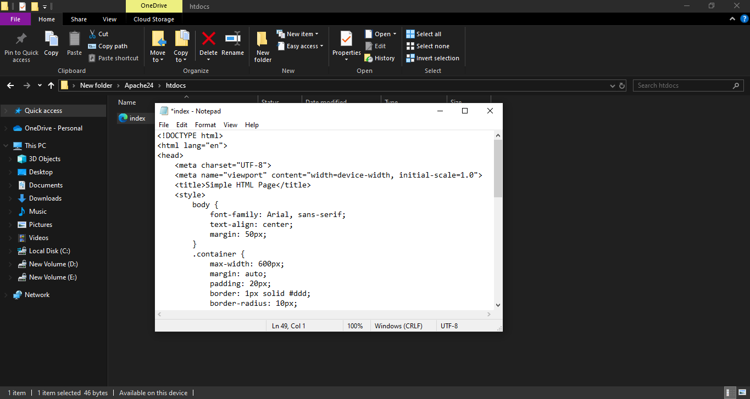

STEP 8:

* Open the Chrome browser and type localhost/index1.html in address bar.
* The website gets displayed successfully.

